**Low Level Design**

Bangalore outlet: Swiggy data analysis

|  |  |
| --- | --- |
| Written by | Mamta M. Natu |
| Document version | 1.0 |

2 LOW LEVEL DESIGN

|  |  |  |  |
| --- | --- | --- | --- |
| Version | Data | Author | Comment |
| 1.0 | 07/03/2023 | Mamta M. Natu |  |

Contents

1.Introduction--------------------------------------------------------------------------03

1.1 What is Low-Level Design Document ----------------------------------------03

1.2 Scope --------------------------------------------------------------------------------0 3

2. Architecture------------------------------------------------------------------------- 03

3. Architecture Description -------------------------------------------------------- 05

3.1 Data Description -----------------------------------------------------------------05

3.2 Web Scrapping -------------------------------------------------------------------05

3.3 Data Transformation------------------------------------------------------------05

3.4 Data insertion-------------------------------------------------------------------- 06

3.6 Deployment ----------------------------------------------------------------------07

4. Unit test cases ---------------------------------------------------------------------07

**1.Introduction**

**1.1 What is Low-Level design document?**

The goal of the LDD or Low-level design document (LLDD) is to give the internal logic design of the

actual program code for the House Price Prediction dashboard. LDD describes the class diagrams

with the methods and relations between classes and programs specs. It describes the modules so

that the programmer can directly code the program from the document.

**1.2 Scope**

Low-level design (LLD) is a component-level design process that follows a step-by-step refinement

process. The process can be used for designing data structures, required software architecture,

source code and ultimately, performance algorithms. Overall, the data organization may be

defined during requirement analysis and then refined during data design work

**2. Architecture**

Power BI Architecture

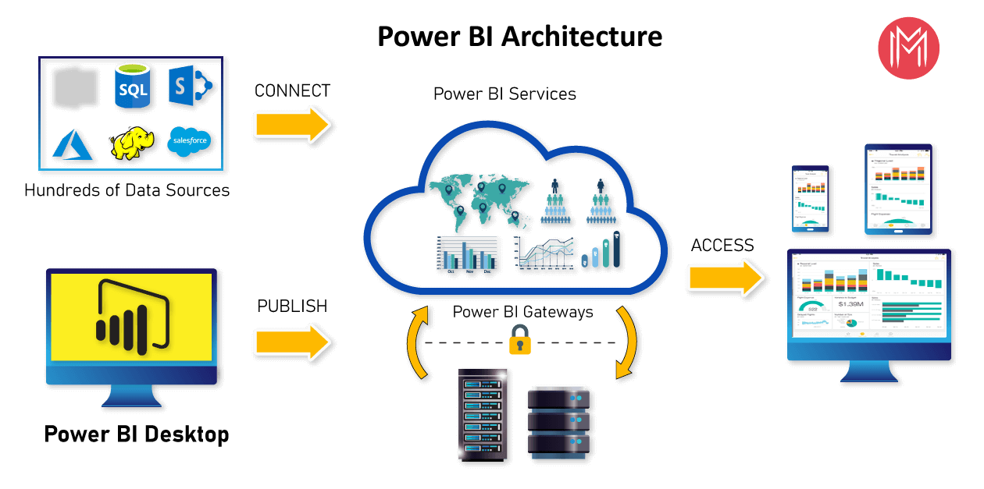

**Components of Power BI Architecture**

**1. Data Sources**

An important component of Power BI is its vast range of data sources. You can import data from files in your system, cloud-based online data sources or connect directly to live connections. If you import from data on-premise or online services there is a limit of 1 GB.

**2. Power BI Desktop**

Power BI Desktop is a client-side tool known as a companion development and authoring tool.

This desktop-based software is loaded with tools and functionalities to connect to data sources, transform data, data modelling and creating reports.

You can download and install Power BI Desktop in your system for free. Using Power BI Desktop features, one can do data cleansing, create business metrics and data models, define the relationship between data, define hierarchies, create visuals and publish reports.

**3. Power BI Service**

Power BI Service is a web-based platform from where you can share reports made on Power BI Desktop, collaborate with other users, and create dashboards.

It is available in three versions:

Free version

Pro version

Premium version

Power BI Service is also known as, “Power BI.com”, “Power BI Workspace”, “Power BI Site” and “Power BI Web Portal”. This component also offers advanced features like natural language Q&A and alerts.

**4. Power BI Report Server**

The Power BI Report Server is similar to the Power BI Service. The only difference between these two is that Power BI Report Server is an on-premise platform. It is used by organizations who do not want to publish their reports on the cloud and are concerned about the security of their data.

Power BI Report Server enables you to create dashboards and share your reports with other users following proper security protocols. To use this service, you need to have a Power BI Premium license.

**5. Power BI Gateway**

This component is used to connect and access on-premise data in secured networks. Power BI Gateways are generally used in organizations where data is kept in security and watch. Gateways help to extract out such data through secure channels to Power BI platforms for analysis and reporting.

**6. Power BI Mobile**

Power BI Mobile is a native Power BI application that runs on iOS, Android, and Windows mobile devices. For viewing reports and dashboards, these applications are used.

**7. Power BI Embedded**

Power BI Embedded offers APIs which are used to embed visuals into custom applications.

**3. Architecture Description**

**3.1. Data Description:**

The Dataset contains Bangalore city swiggy data with five columns and 114 records of swiggy outlets in different locations in the city. Shop name column with different cuisine type. Two numeric columns viz. cost of food for two persons and ratings of that outlets.

The columns are:

1)Shop Name: Names of different shops in city which are swiggy outlets.

2) Cuisine: Types of cuisines that shops serving as. E.g. North Indian, Chines etc.

3) Location: Gives location of that shop in Bangalore city.

4) Cost of two : Cost of ordering food from that outlet for two persons.

This is numeric column with currency datatype in Indian rupees.

5) Ratings: Ratings given by customers to that outlet.

**3.2 web scraping**

Extract Transform Load:

3.2.(a) Extract (for python EDA)

1)To extract data using web scraping with python, you need to follow these basic steps:

2)Find the URL that you want to scrape.

3)Inspecting the Page.

4)Find the data you want to extract.

5)Write the code.

6)Run the code and extract the data.

7)Store the data in the required format.

3.2(b): Importing data from web to excel. (For PowerBi visualisation)

1) Press CTRL+V to paste the URL into the text box, and then select OK.

2) In the Navigator pane, under Display Options, select the Results table.  
3) Power Query will preview it for you in the Table View pane on the right.

4) Select Load. Power Query transforms the data and loads it as an Excel table.

**3.3. Transform the Data Based on Requirements**

1) Remove the first null row:

**2)** Remove Unnecessary Rows

We want to remove all the unnecessary rows to make our data more readable in the next step.

3)Select the first column, drop down the list by “**Left-Click**.”

**Deselect** all the items you don’t want in your datasheet.

Click on**“OK.”**

4) Rename Column Headings

The most straightforward task in Power BI is to Rename the column heading.

**“Double Click”** on the column heading will get highlighted with a blue mark, then replace the name with a new header.

**5) Separating into two Columns**

Now what we want is to split the name and employee id into their column.

Select the column “**Right-Click**” on the column heading.

A drop-down list will appear; select **“Split Column**.”

 Then we go for “**By Delimiter**” to split the column.

4. The ‘Split Column by Delimiter ‘page appears; we want to separate the column from the open parenthesis; thus, we customize the option and fill “(“  in the box.”

5. Click on “**OK.”**

6.Change Data Type

If we want to change the data type:

Select the column and “Right-Click” on the column header.

A drop-down list will appear; select “Change Type.”

Now, again a drop-down list will appear with different data types. Select the data type according to you.

**3.4 Data insertion (Load data):**

As soon as you are done with the data transformation procedure, save the query.

Go to the “**Home”** tab and click on the “**Close & Apply**” button to save the data. It is the final step that will load your data.

**3.5 Deployment:**

To publish a Power BI Desktop dataset and reports

In Power BI Desktop, choose **File** > **Publish** > **Publish to Power BI** or select **Publish** on the **Home** ribbon.

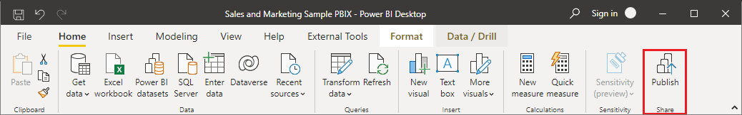

Sign in to Power BI if you aren't already signed in.

Select the destination. You can search your list of available workspaces to find the workspace into which you want to publish. The search box lets you filter your workspaces. Select the workspace, and then click the **Select** button to publish.

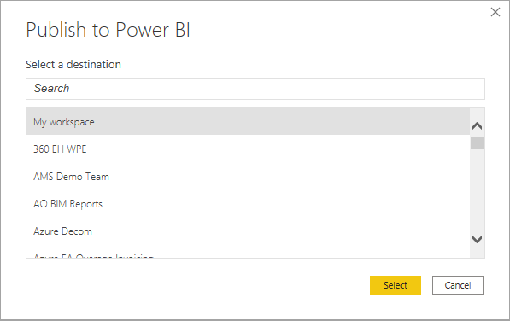

When publishing is complete, you receive a link to your report. Select the link to open the report in your Power BI site.

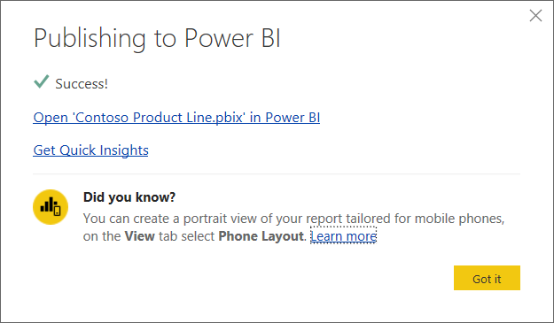

.

**4. Unit Test Cases**

|  |  |
| --- | --- |
| TEST CASE DESCRIPTION | EXPECTED RESULTS |
| Location Slicer | When clicked on the slicer tile, it selects the location. |
| Cuisine Type | When clicked on the slicer, a dropdown should occur which has various cuisine types. |
| Page Navigator | Selecting page, we want to see the result. |
| Clear button | Clears all the filters on report |